Family Services
Bishop Online Referral
Step-by-Step Guide

This guide will walk you through creating a new referral for a member of your ward to begin working with a counselor at Family Services. Using this online resource, will ensure that your local Family Services office has all the information needed to get started as soon as possible with counseling services for the individual or couple.

After you have entered in the referral, a counselor will contact you to confirm that your referral was received and will get any additional information that you might have for them. If after following these steps you are having any problems, please feel free to contact your local office for support.

Step One: Login
- Open a browser and go to www.churchofjesuschrist.org . Click on My Account and Ward and click the Sign In button.

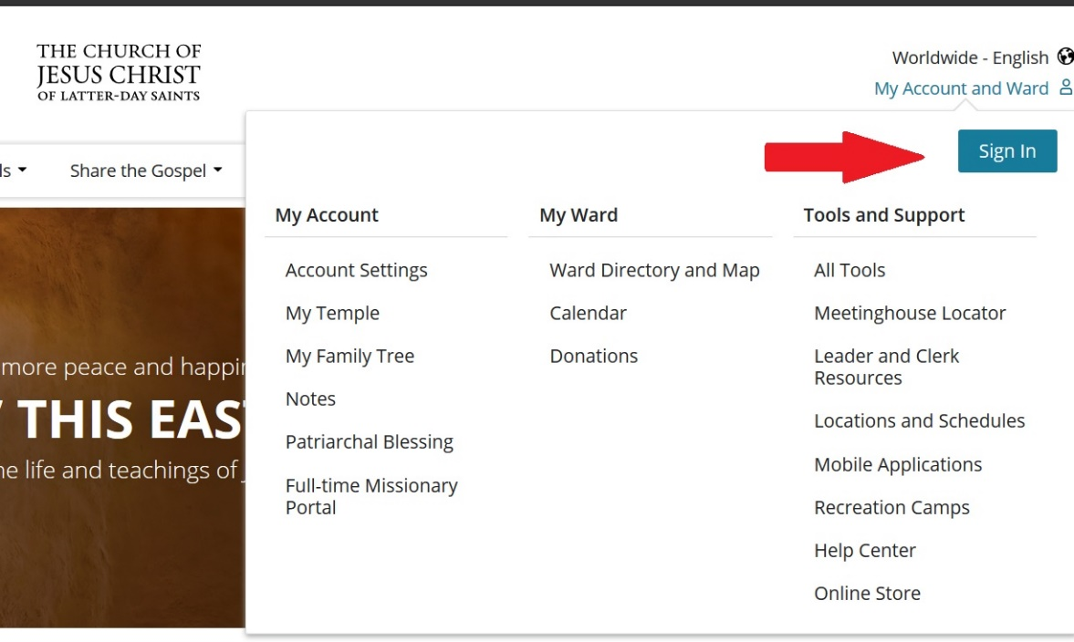

- Then enter your user name and password.
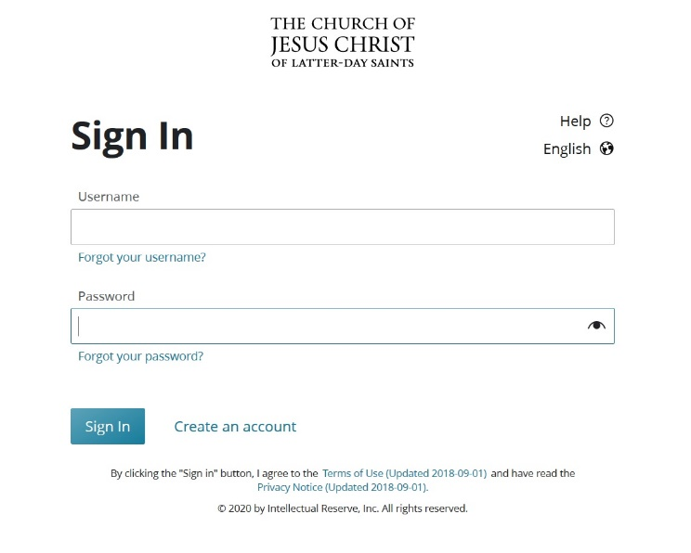
Step Two: Go to Leader and Clerk Resources
- Click on your name in the top right corner and select Leader and Clerk Resources under the Tools and Support menu.
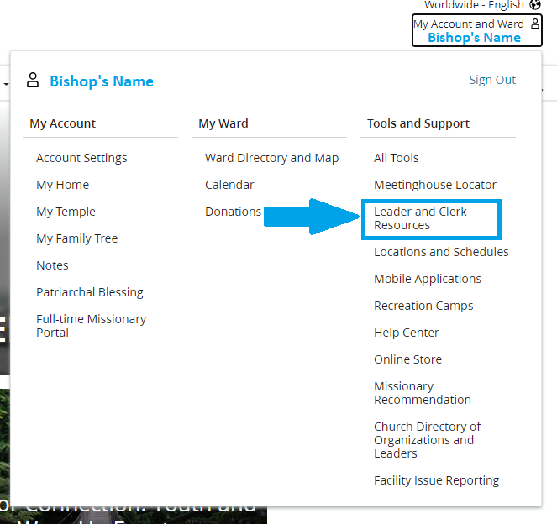

Step Three: Open Welfare Resource Order Dashboard
- Click on the Other menu and select Welfare and Self-Reliance Leader Resources.
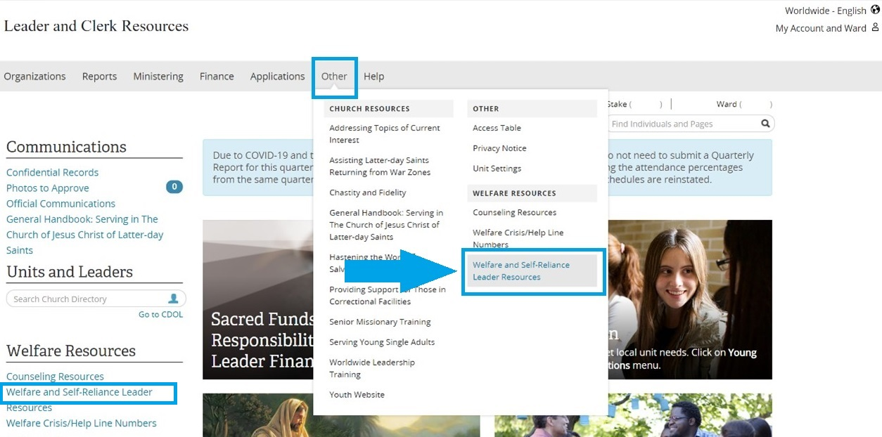

Step Four: Open Forms and Resources
- Click on the Forms and Resources button to the top right on the dashboard.
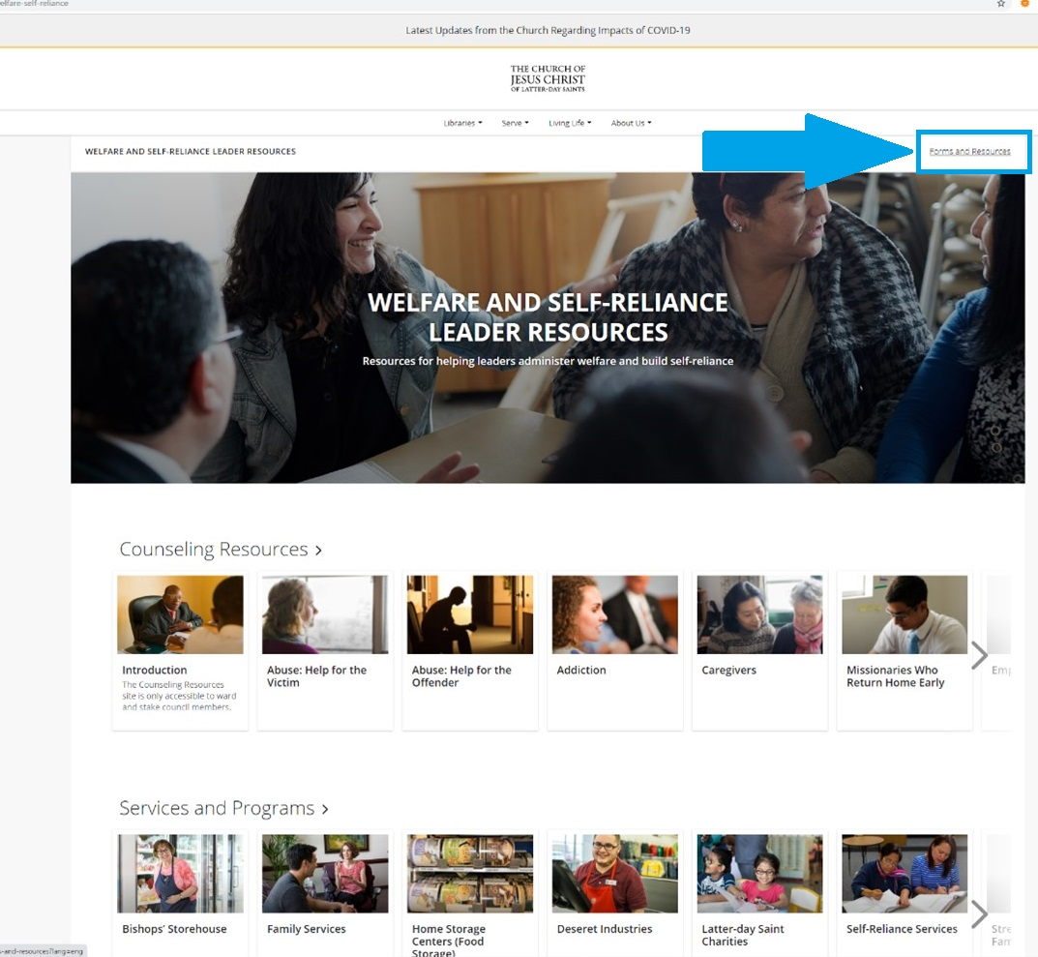

Step Five: Open Bishops’ Storehouse Online Orders
- Click the first box Bishops’ Storehouse Online Orders button on the top left.
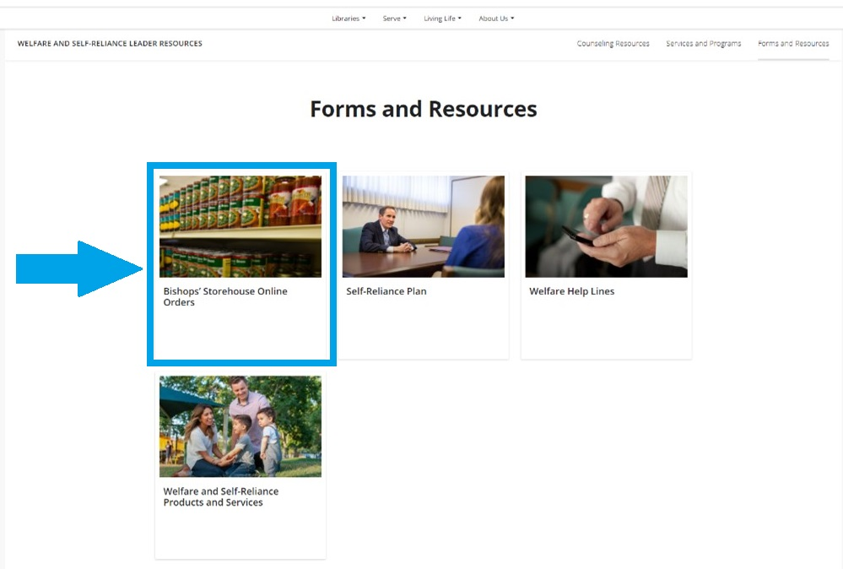
Step Six: Select Referral
- Click the Referral button on the top right.
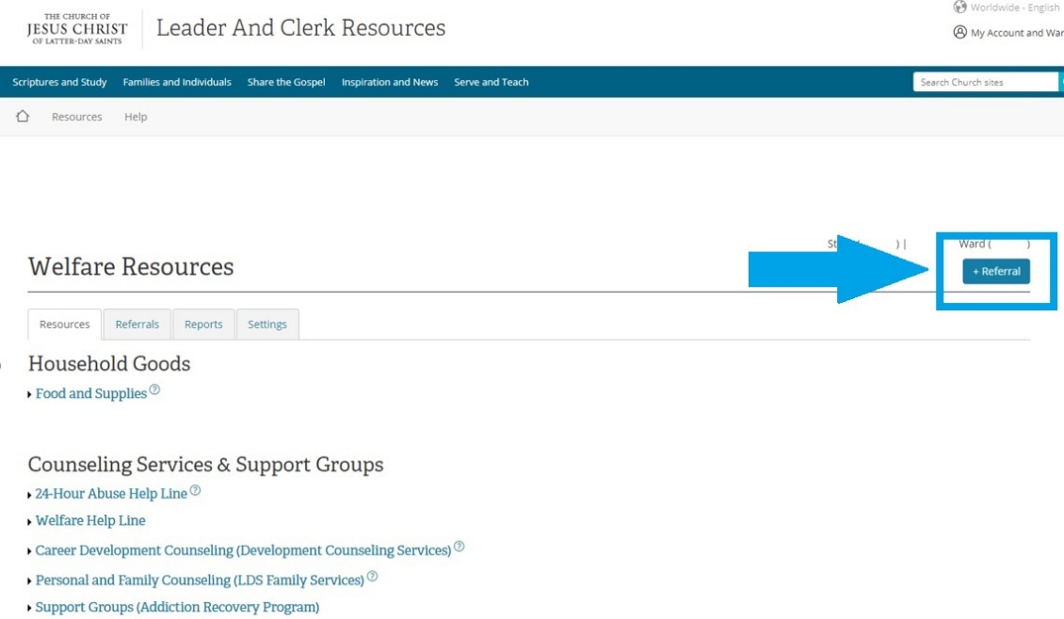
Step Seven: Fill out the referral
- Click in the Select Head of Household of Member field and start typing the name of the person you want to refer. Their record must be in your ward in order for them to come up on this list. Then click on the name to add it to the field.
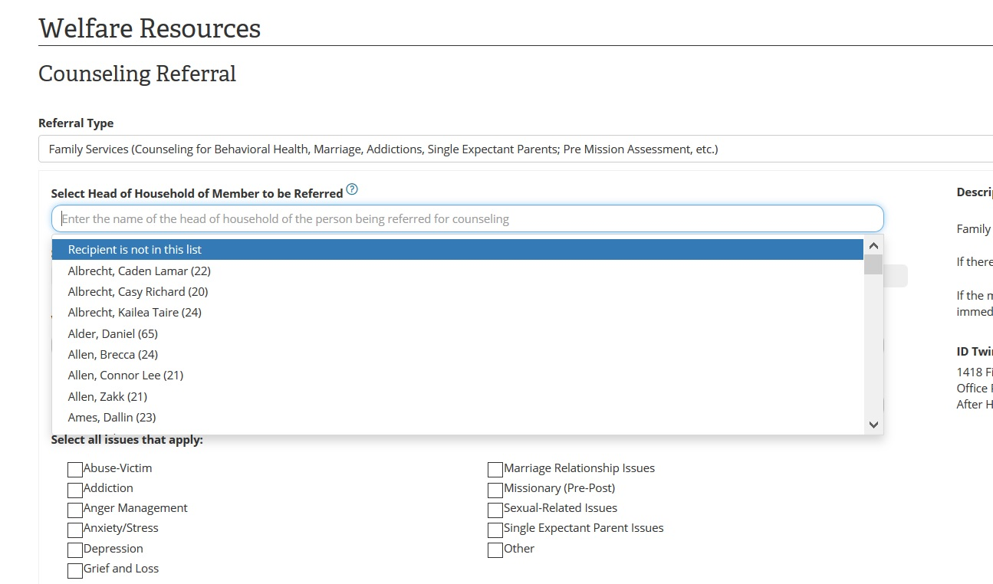
- Click in the Visit Type field and choose one of the 5 options from the drop-down list.
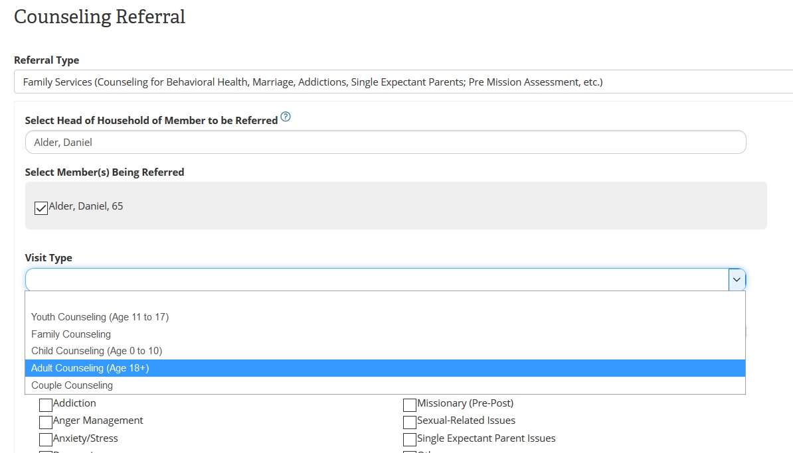
- The members phone number will pre-populate. If you are with the member please confirm that is the best contact number. Then Select all issues that apply by checking all applicable boxes.
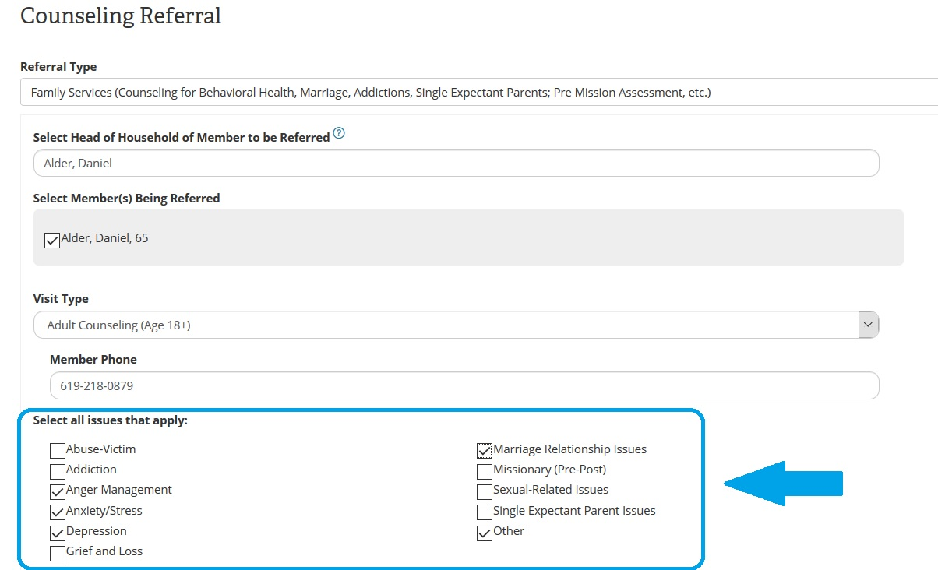
- Click in the Briefly Summarize Reason for Referral field and share purpose of visit.
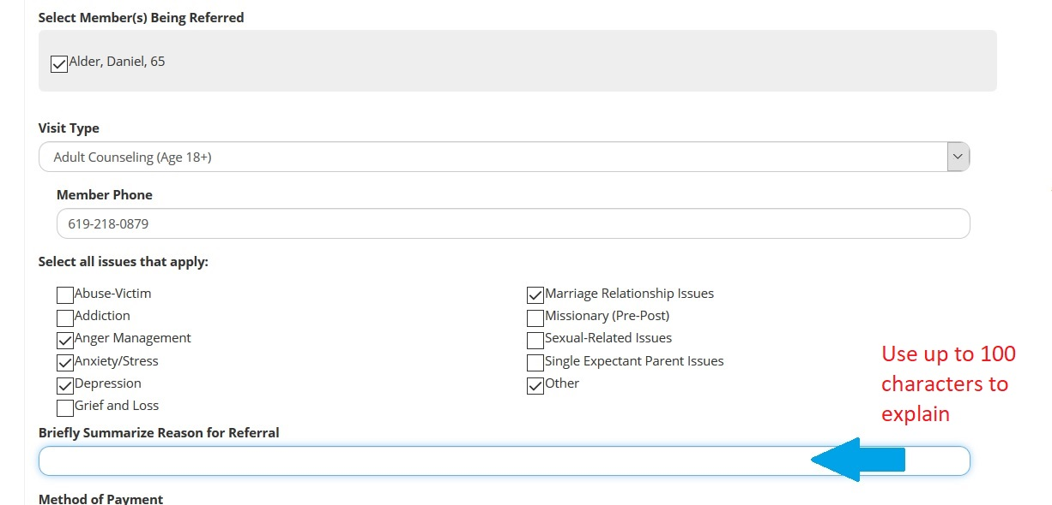

- Click in the Method of Payment field and select from the 5 choice in the drop-down list.
  - NOTE: Family Services does not bill insurance. The member will need to submit this for reimbursement after they pay their bill with Family Services.
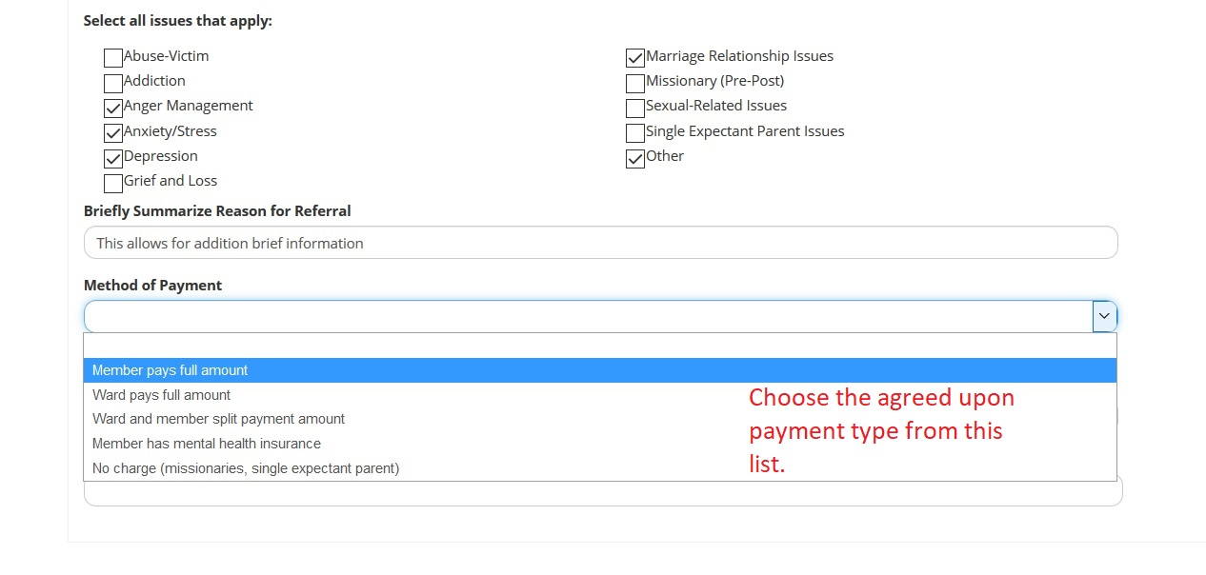
- Review Your Phone Number field. You can change this number as needed.
- Enter Please specify the best time field when we can contact you. Then click Submit.
